|  |  |
| --- | --- |
| **Date** | **16 November 2022** |
| **Team ID** | **PNT2022TMID26844** |
| **Project Name** | **PROJECT - SMART CROP PROTECTION SYSTEM FOR AGRICULTURE** |

**SPRINT 3**

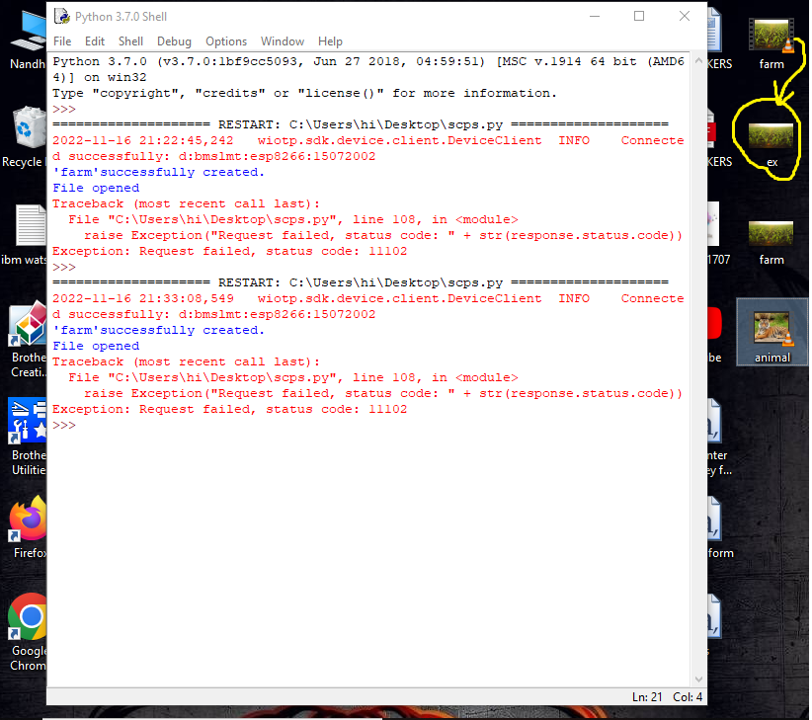

After creating a data base in cloudant DB, my local video mp4 file is converted to ex.jpg file as per the program code and also I manually created labeling in clarifai service account but also it shows same error code as :11102(invalid request).